SPARK SQL:

What Is Spark SQL?
Spark SQL is a module in Apache Spark that allows you to work with structured data using SQL queries that runs on Spark’s distributed engine. It integrates seamlessly with Spark’s core engine and supports querying data via:
- SQL syntax
- DataFrame API
- HiveQL (if Hive is integrated)
🧠 Key Features of Spark SQL
Feature | Description
Unified Data Access | Query data from Hive, Parquet, JSON, JDBC, and more using a common interface
SQL + Code Integration | Mix SQL queries with Python, Scala, or Java code
Performance Optimized | Uses Catalyst optimizer and Tungsten engine for fast execution
Distributed Processing | Handles massive datasets across clusters with fault tolerance
Supports BI Tools | Connects via JDBC/ODBC for tools like Power BI or Tableau

Using SQL in spark dataframe:
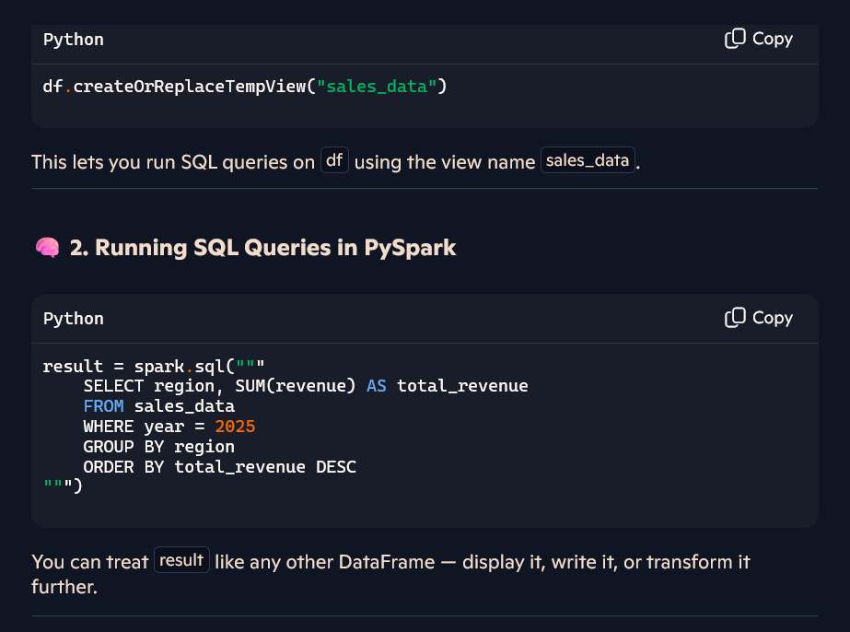
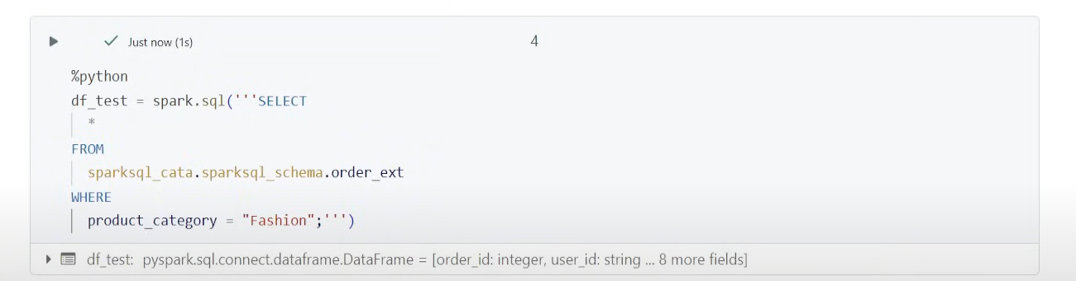

TempView:

📘 Definitions
🔹 TempView
A TempView is a temporary logical table created from a DataFrame that exists only within the current Spark session. It allows you to run SQL queries on the DataFrame using Spark SQL.
- Scope: Local to the session
- Lifetime: Ends when the session ends
- Usage: Ideal for intermediate transformations, debugging, or notebook-specific logic
df.createOrReplaceTempView("my_temp_view")
spark.sql("SELECT * FROM my_temp_view").show()

🔹 GlobalTempView
A GlobalTempView is a temporary logical table that is accessible across all Spark sessions within the same Spark application. It’s stored in a system database called global_temp.
- Scope: Global across sessions
- Lifetime: Ends when the Spark application ends
- Usage: Useful for sharing data across notebooks, jobs, or tasks
- GlobalTempView cannot be created in serverless compute.
df.createOrReplaceGlobalTempView("my_global_view")
spark.sql("SELECT * FROM global_temp.my_global_view").show()

📊 Comparison Table
Feature | TempView | GlobalTempView
Scope | Current Spark session | All sessions in the Spark application
Lifetime | Ends with session | Ends with Spark application
Access | "view_name" | "global_temp.view_name"
Use Case | Notebook-specific logic | Shared logic across notebooks/jobs
Storage Location | Session memory | global_temp database

🧠 Pro Tip for Databricks & ADF Workflows
- Use TempView for isolated transformations or debugging within a single notebook.
- Use GlobalTempView when passing intermediate results between notebooks or jobs.
- For persistent storage, prefer Delta tables or managed tables.
Would you like a visual diagram showing their scopes and lifetimes for your educational content? I can sketch one that fits your slide style perfectly.

Managed Table and External Table:

📘 Definitions
🔹 Managed Table
A Managed Table (also called an internal table) is fully controlled by Databricks. When you create it, Databricks:
- Stores the data in a default location (usually under /user/hive/warehouse or Unity Catalog path)
- Manages the metadata and lifecycle
- Deletes both data and metadata when you drop the table
df.write.saveAsTable("my_managed_table")
🧾 Use Case:
- Ideal when Databricks is your primary platform
- Simplifies cleanup and lifecycle management
- Great for internal users with SQL access

🔹 External Table
An External Table references data stored outside Databricks-managed locations (e.g., Azure Blob, ADLS, S3). Databricks manages only the metadata, not the data files.
CREATE TABLE my_external_table
USING DELTA
LOCATION 'abfss://mycontainer@myaccount.dfs.core.windows.net/data/external_table/'
🧾 Use Case:
- When you need direct access from other tools or platforms
- Useful for shared data lakes or multi-tool ecosystems
- Dropping the table does not delete the data

📊 Comparison Table
Feature | Managed Table | External Table
Data Location | Databricks-controlled | External storage (e.g., ADLS, S3)
Metadata Management | Fully managed by Databricks | Only metadata managed
Data Lifecycle | Data deleted on DROP TABLE | Data persists after DROP TABLE
Access Flexibility | Limited to Databricks | Accessible from external systems
Use Case | Internal workflows, SQL users | Shared lakehouse, multi-tool access

🧠 Pro Tip for You
Since you're working with ADF + Databricks, use:
- Managed tables for staging, intermediate results, and internal dashboards
- External tables for long-term storage, shared datasets, or cross-platform access

Catalog, Schema and Table:
🗂️ Catalog: The Top-Level Container
- Think of a catalog as a data governance boundary or a top-level namespace.
- It contains multiple schemas (also called databases).
- In Unity Catalog, each catalog can have its own access controls, making it ideal for separating environments like dev, prod, or different business units.
Example:
USE CATALOG sales_data;
This switches your context to the sales_data catalog.
📁 Schema (or Database): Logical Grouping Within a Catalog
- A schema is a collection of tables, views, and functions.
- It helps organize data by subject area—like customer, inventory, or finance.
- Schemas live inside catalogs.
Example:
USE sales_data.customer_schema; SELECT * FROM orders;
This accesses the orders table inside the customer_schema schema, which is part of the sales_data catalog.
🧠 Hierarchy Summary
Level | Description | Example Usage
Catalog | Top-level container for schemas | sales_data, marketing_data
Schema | Grouping of tables/views/functions | customer_schema, finance_schema
Table | Actual data storage unit | orders, transactions
🔐 Why It Matters in Lakehouse
- Security: Catalogs and schemas allow fine-grained access control.
- Organization: Helps manage thousands of tables across teams.
- Scalability: Supports multi-tenant architecture and data isolation.

Catalog vs Schema: Clean Breakdown
Concept | Description | Example Name | SQL Create Statement
Catalog | Top-level container for schemas; defines governance boundary | finance_catalog | CREATE CATALOG finance_catalog;
Schema | Logical grouping of tables/views/functions within a catalog | customer_data | CREATE SCHEMA finance_catalog.customer_data;

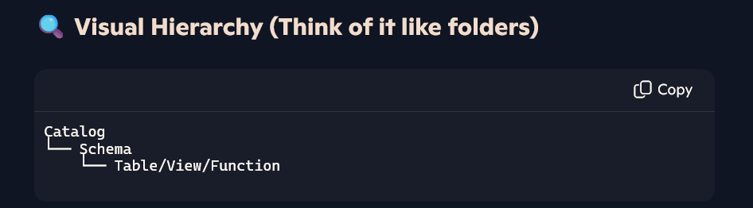
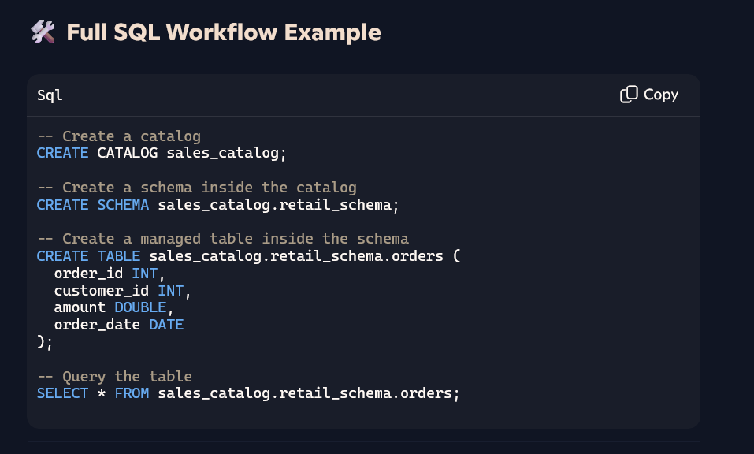

CTAS
📘 What is CTAS?
CTAS stands for Create Table As Select.
It’s a SQL command that:
- Creates a new table
- Populates it with data from a SELECT query
- Optionally applies transformations, filters, or joins during creation

🔧 Syntax
CREATE TABLE new_table_name
AS
SELECT column1, column2, ...
FROM source_table
WHERE condition;

🧪 Example in Databricks or Spark SQL
Let’s say you have a table sales_data.orders and you want to create a new table with only high-value orders:
CREATE TABLE high_value_orders
AS
SELECT order_id, customer_id, amount
FROM sales_data.orders
WHERE amount > 10000;
✅ This creates high_value_orders and fills it with filtered data from orders.

🧠 Why CTAS Is Efficient
- One-step creation + population: No need for separate CREATE and INSERT
- Supports transformations: You can apply filters, joins, aggregations
- Optimized for performance: Especially in Spark, CTAS can trigger optimized execution plans

⚠️ Notes
- In Databricks, CTAS creates a managed table by default unless you specify LOCATION for external storage.
- You can also use CTAS with formats like Delta:
CREATE TABLE delta.`/mnt/data/high_value_orders`
AS
SELECT * FROM orders WHERE amount > 10000;

UNDROP in Databricks:

🧠 What Is UNDROP?
UNDROP allows you to restore a dropped table or materialized view within a retention period (typically 7 days) if it was managed under Unity Catalog.

🛠️ Syntax
UNDROP TABLE catalog.schema.table_name;
Or, if multiple versions were dropped:
UNDROP TABLE WITH ID 'table_id';
You can find the table_id using:
SHOW TABLES DROPPED IN catalog.schema;

✅ How It Works
- Retention: When you drop a table, Unity Catalog retains its metadata and data for 7 days.
- Recovery: You can run UNDROP to restore the most recent version.
- Scope: Works for managed tables, external tables, and materialized views.
- Permissions Required:
  - USE CATALOG, USE SCHEMA, and CREATE TABLE
  - Ownership or MANAGE privilege on the dropped object

⚠️ Limitations
- Only Unity Catalog objects are supported.
- Streaming tables and materialized views can only be restored if their backing pipeline still exists.
- Primary/foreign key constraints are not recovered—you must reapply them manually.

🔍 Example
-- Recover a dropped table
UNDROP TABLE finance_catalog.customer_data.orders;

-- Recover a specific version by ID
UNDROP TABLE WITH ID 'a1b2c3d4-e5f6-7890-gh12-ijklmnopqrst';

FILTERING in SQL
🧠 Pro Tips for Efficient Filtering
- Use indexed columns in your WHERE clause for faster performance
- Avoid filtering on computed expressions (e.g., WHERE YEAR(order_date) = 2025)—rewrite to use raw columns
- Use parameterized queries in Python/ADF pipelines to avoid SQL injection and improve reusability
Filtering means selecting rows from a table based on specific conditions using the WHERE clause. It helps you narrow down results to only the data that meets your criteria.

🧠 SQL Filtering Cheat Sheet
🔍 1. WHERE Clause Basics
Used to filter rows based on conditions.
SELECT * FROM employees
WHERE department = 'Sales';

🔡 2. LIKE — Pattern Matching
Pattern | Meaning | Example
% | Any sequence of characters | 'A%' matches "Alice", "Adam"
_ | Single character | 'A_%' matches "Amy", "Ann"
SELECT * FROM customers
WHERE name LIKE 'J%n'; -- Matches "John", "Jason"

📦 3. IN — Match Multiple Values
SELECT * FROM orders
WHERE status IN ('Pending', 'Processing', 'Shipped');
✅ Equivalent to multiple OR conditions:
WHERE status = 'Pending' OR status = 'Processing' OR status = 'Shipped'

📅 4. BETWEEN — Range Filtering
SELECT * FROM products
WHERE price BETWEEN 100 AND 500;
📌 Includes both boundary values (100 and 500).

🚫 5. NOT — Negation
SELECT * FROM users
WHERE country NOT IN ('India', 'USA');
SELECT * FROM logs
WHERE message NOT LIKE '%error%';

🔢 6. Comparison Operators
Operator | Meaning
= | Equal
!= or <> | Not equal
> | Greater than
< | Less than
>= | Greater than or equal
<= | Less than or equal
SELECT * FROM inventory
WHERE quantity >= 10;

🧮 7. IS NULL / IS NOT NULL
SELECT * FROM payments
WHERE transaction_id IS NULL;
SELECT * FROM payments
WHERE transaction_id IS NOT NULL;

🧠 Bonus: Combine Filters with AND / OR
SELECT * FROM employees
WHERE department = 'IT'
AND salary > 60000
OR location = 'Remote';

SQL Warehouse in Databricks:

🏗️ What Is a SQL Warehouse in Databricks?
A SQL Warehouse (formerly called SQL Endpoint) is a compute resource in Databricks designed specifically for running SQL queries on your data lake. It powers dashboards, BI tools, and ad hoc SQL analysis — all with scalable performance.

⚙️ Key Features
- Runs on your data lake using the Lakehouse architecture
- Supports standard SQL syntax and BI integrations (Power BI, Tableau, etc.)
- Can be serverless, meaning Databricks handles provisioning, scaling, and optimization
- Used in Databricks SQL workspace for query editing, visualization, and metric definitions

🧠 Why Use SQL Warehouses?
Benefit | Description
💨 Fast & Elastic | Serverless warehouses scale instantly based on workload
💰 Cost-Efficient | No idle compute — pay only for what you use
📊 BI-Friendly | Easily connect to tools like Power BI, Excel, or Tableau
🔒 Secure | Fine-grained access control and workspace integration

🛠️ How You Use It
- Create or use a SQL Warehouse from the Databricks SQL workspace
- Attach notebooks or dashboards to the warehouse
- Run SQL queries like:
SELECT region, SUM(sales) AS total_sales
FROM sales_data
WHERE year = 2025
GROUP BY region;
- Visualize results or export to BI tools

🚀 Serverless vs Pro Warehouses
Type | Description
Serverless | Auto-scales, no setup, ideal for BI and ad hoc queries
Pro | Manually configured, more control over resources
Databricks recommends serverless warehouses for most use cases due to their simplicity and performance.

Aggregations:

🧠 What Is GROUP BY?
The GROUP BY clause groups rows that have the same values in specified columns, allowing you to apply aggregate functions like SUM(), COUNT(), AVG(), MAX(), and MIN() to each group.

🔧 Syntax
SELECT column1, AGG_FUNCTION(column2)
FROM table_name
GROUP BY column1;

📊 Common Aggregate Functions
Function | Description | Example
SUM() | Total of values | SUM(sales)
COUNT() | Number of rows | COUNT(*) or COUNT(customer_id)
AVG() | Average value | AVG(revenue)
MAX() | Highest value | MAX(score)
MIN() | Lowest value | MIN(price)

🧪 Example: Total Sales by Region
SELECT region, SUM(sales) AS total_sales
FROM orders
GROUP BY region;
✅ This returns one row per region with the total sales.

🔁 Example: Count of Orders per Customer
SELECT customer_id, COUNT(order_id) AS order_count
FROM orders
GROUP BY customer_id;

🧠 Advanced Example: Multiple Grouping Columns
SELECT region, product_category, AVG(revenue) AS avg_revenue
FROM sales_data
GROUP BY region, product_category;
This groups by both region and product_category.

⚠️ Tips for Using GROUP BY
- Every column in the SELECT clause must be either:
  - In the GROUP BY clause
  - Or wrapped in an aggregate function
- You can use HAVING to filter after aggregation:
SELECT region, SUM(sales) AS total_sales
FROM orders
GROUP BY region
HAVING SUM(sales) > 100000;

SQL order of execution:
Here’s the true order of SQL execution, step-by-step:

🧠 SQL Execution Order (Behind the Scenes)
Step | Clause | Description
1️⃣ | FROM | Loads tables and joins them
2️⃣ | ON | Applies join conditions
3️⃣ | JOIN | Combines rows from multiple tables
4️⃣ | WHERE | Filters rows before grouping
5️⃣ | GROUP BY | Groups rows for aggregation
6️⃣ | HAVING | Filters groups after aggregation
7️⃣ | SELECT | Projects columns and expressions
8️⃣ | DISTINCT | Removes duplicate rows
9️⃣ | ORDER BY | Sorts the result set
🔟 | LIMIT / OFFSET | Restricts number of rows returned

🔍 Example Query
SELECT region, SUM(sales) AS total_sales
FROM orders
WHERE year = 2025
GROUP BY region
HAVING SUM(sales) > 100000
ORDER BY total_sales DESC
LIMIT 10;
How It Actually Executes:
- FROM: Load orders table
- WHERE: Filter rows where year = 2025
- GROUP BY: Group by region
- HAVING: Keep only groups with SUM(sales) > 100000
- SELECT: Return region and SUM(sales)
- ORDER BY: Sort by total_sales
- LIMIT: Return top 10 rows

🧠 Pro Tip
- You cannot use aliases from SELECT in WHERE or GROUP BY because those clauses are evaluated before SELECT.
- Use subqueries or CTEs if you need to reference computed columns earlier in the execution.

CASE statement usage:
Absolutely, Ganapathi — let’s enrich the explanation with a clear definition of the CASE expression in SQL, right at the top for completeness.

📘 Definition: What Is CASE in SQL?
The CASE expression in SQL is a conditional logic construct that allows you to return different values based on specified conditions. It’s similar to if-else statements in programming languages and is used to make queries more dynamic and readable.
You can use CASE in:
- SELECT (to create derived columns)
- WHERE (to apply conditional filters)
- ORDER BY (to sort conditionally)
- GROUP BY or HAVING (for conditional aggregation)
- UPDATE or MERGE (for conditional data manipulation)

🔧 Syntax Recap
CASE
WHEN condition1 THEN result1
WHEN condition2 THEN result2
...
ELSE default_result
END
Or the simple form:
CASE column_name
WHEN value1 THEN result1
WHEN value2 THEN result2
ELSE default_result
END

🧪 Examples Recap
1. Categorize Salaries
SELECT name, salary,
CASE
WHEN salary >= 100000 THEN 'High'
WHEN salary >= 50000 THEN 'Medium'
ELSE 'Low'
END AS salary_band
FROM employees;
2. Conditional Aggregation
SELECT department_id,
SUM(CASE WHEN gender = 'Male' THEN 1 ELSE 0 END) AS male_count,
SUM(CASE WHEN gender = 'Female' THEN 1 ELSE 0 END) AS female_count
FROM employees
GROUP BY department_id;
3. Sort with NULL Handling
SELECT name, hire_date
FROM employees
ORDER BY
CASE
WHEN hire_date IS NULL THEN 1
ELSE 0
END, hire_date;

⚙️ Pro Tips
- Keep conditions efficient — avoid heavy computations inside CASE.
- Combine with COALESCE, NULLIF, or ISNULL for robust null handling.
- Use in MERGE or UPDATE to apply conditional logic during data transformation.

Subquery in SQL:

🧠 What Is a Subquery?
A subquery (or inner query) is a query embedded within another SQL query. It returns a result that the outer query uses — like a temporary table or value.
You can use subqueries in:
- SELECT clause
- FROM clause
- WHERE clause
- HAVING clause

🔍 Types of Subqueries
Type | Description | Example Use Case
Scalar Subquery | Returns a single value | Get max salary from a department
Column Subquery | Returns a single column with multiple rows | List employees in departments with >10
Row Subquery | Returns multiple columns but one row | Match exact employee profile
Table Subquery | Returns a full result set (used in FROM) | Join with a filtered dataset
Correlated Subquery | Depends on outer query for its values; runs per row | Find employees earning above dept average

🧪 Example 1: Scalar Subquery in SELECT
SELECT name,
(SELECT MAX(salary) FROM employees) AS max_salary
FROM employees;
Adds a column showing the highest salary across all employees.

🧪 Example 2: Subquery in WHERE
SELECT name, salary
FROM employees
WHERE salary > (SELECT AVG(salary) FROM employees);
Returns employees earning above average.

🧪 Example 3: Correlated Subquery
SELECT e.name, e.salary
FROM employees e
WHERE e.salary > (
SELECT AVG(salary)
FROM employees
WHERE department_id = e.department_id
);
Compares each employee’s salary to their department’s average.

⚙️ Optimization Tips
- Avoid correlated subqueries on large datasets — they can be slow.
- Use JOINs or CTEs if performance is critical.
- Index columns used in subquery filters.

Example for Column Subquery:
📌 Column Subquery
A column subquery returns a single column with multiple rows. It’s often used with , , or in joins.
🔸 Example: Employees in High-Revenue Departments
SELECT name, department_id
FROM employees
WHERE department_id IN (
SELECT id
FROM departments
WHERE revenue > 1000000
);
✅ What’s happening:
• The subquery returns a column of department IDs.
• The outer query filters employees who belong to those departments.

Row Subquery
A row subquery returns multiple columns but only one row. It’s used with , , or in comparisons like , .
🧪 Scenario: Find the employee who matches the highest salary and department of a specific employee
Let’s say you want to find the employee who has the same salary and department as the employee named 'Ravi'.
SELECT name, salary, department_id
FROM employees
WHERE (salary, department_id) = (
SELECT salary, department_id
FROM employees
WHERE name = 'Ravi'
);
✅ What’s happening:
- The subquery returns one row with two columns: Ravi’s salary and department.
- The outer query finds all employees who match both values.
This is a classic row subquery because:
- It returns exactly one row with multiple columns.
- The outer query compares a tuple (salary, department_id) to the result.
⚠️ Important Notes:
- If the subquery returns more than one row, it will throw an error.
- You can only use row subqueries with operators that support tuple comparison like =, <>, IN, etc.

Limitations & Behavior Row Subqueries in Spark SQL
Unlike traditional RDBMS like SQL Server or Oracle, Spark SQL has limited support for row subqueries, especially when comparing tuples like (col1, col2) = (subquery).
🔴 What doesn’t work well:
SELECT name FROM employees WHERE (salary, department_id) = ( SELECT salary, department_id FROM employees WHERE name = 'Ravi' );
This may fail or behave unpredictably in Spark SQL due to lack of tuple comparison support.

Recommended Rewrite Using JOIN
Instead of relying on a row subquery, use a JOIN to bring in the reference values:
SELECT e.name, e.salary, e.department_id
FROM employees e
JOIN (
SELECT salary, department_id
FROM employees
WHERE name = 'Ravi'
) ref
ON e.salary = ref.salary AND e.department_id = ref.department_id;

🔹 Advantages:
- Fully supported in Spark SQL
- Scales better on distributed data
- Easier to optimize with broadcast joins if ref is small

Alternative Rewrite Using CTE
If you prefer clarity and modularity, a CTE (Common Table Expression) works beautifully:
WITH RaviProfile AS (
SELECT salary, department_id
FROM employees
WHERE name = 'Ravi'
)
SELECT e.name, e.salary, e.department_id
FROM employees e
JOIN RaviProfile r
ON e.salary = r.salary AND e.department_id = r.department_id; 🔹 Benefits:
- Improves readability
- Easier to debug and extend
- Compatible with Spark SQL and Synapse
🚀 Performance Tuning Tips for Spark
- Broadcast small reference tables using broadcast() in PySpark or hints in SQL
- Cache intermediate results if reused across stages
- Avoid nested subqueries in large joins — flatten logic with CTEs or temp views
- Use Delta Lake optimizations like Z-Ordering and data skipping for faster filtering

Window Function:
A window function performs a calculation across a set of rows that are related to the current row — without collapsing the result set.
Unlike aggregate functions (like , , ) that group and reduce rows, window functions retain individual rows and add computed values alongside them.
1. Core Concepts
- OVER clause
Defines the window:
  - PARTITION BY splits rows into groups
  - ORDER BY defines ordering within each partition
- Frame
Optionally limits the rows in the partition (e.g., ROWS BETWEEN UNBOUNDED PRECEDING AND CURRENT ROW)

ROW_NUMBER()
Assigns a unique sequential integer to each row within a partition, based on the specified order. There are no ties—every row gets its own number.
SELECT
employee_id,
department_id,
salary,
ROW_NUMBER() OVER (
PARTITION BY department_id
ORDER BY salary DESC
) AS rn
FROM employees;
- Rows in each department are numbered 1, 2, 3… in descending salary order.
- No gaps, even if salaries repeat.

RANK()
Gives the same rank to tied rows but leaves gaps after ties.
SELECT
employee_id,
department_id,
salary,
RANK() OVER (
PARTITION BY department_id
ORDER BY salary DESC
) AS rnk
FROM employees;
- If two people share the highest salary, both get rank 1.
- The next distinct salary gets rank 3 (gap of 2).

DENSE_RANK()
Like RANK() but without gaps after ties.
SELECT
employee_id,
department_id,
salary,
DENSE_RANK() OVER (
PARTITION BY department_id
ORDER BY salary DESC
) AS drnk
FROM employees;
- Tied top salaries both rank 1.
- The next distinct salary ranks 2 (no gap).

5. Comparison Table
Function | Tie Behavior | Gaps After Ties? | Use Case
ROW_NUMBER() | No ties (unique IDs) | No | When every row must be uniquely numbered
RANK() | Ties share same rank | Yes | When you need to preserve ordinal positions
DENSE_RANK() | Ties share same rank | No | When you want sequential ranking without gaps

6. When to Use Which
- ROW_NUMBER()
Pick when you need a stable, unique row identifier—e.g., top-N filtering.
- RANK()
Use to reflect true ordinal positions and when gaps matter—e.g., leaderboard standings.
- DENSE_RANK()
Ideal for category labels or grouping without leaving unused ranks.
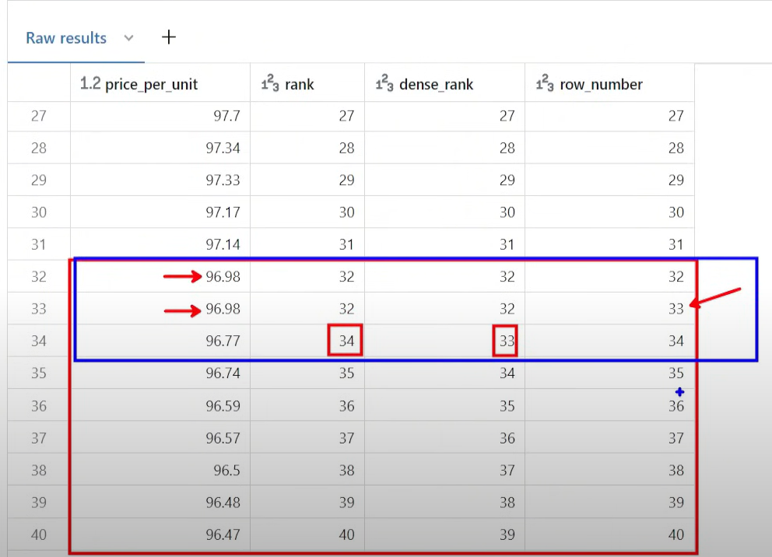

FRAMES
Window Frame in SQL
A window frame defines the subset of rows within each partition that a window function operates on. While PARTITION BY splits the data into groups and ORDER BY sequences them, the frame clause narrows the focus to a sliding window of rows around the current row.

Frame Types
- ROWS
Counts physical offsets from the current row
- RANGE
Uses logical offsets based on the ordering column’s values

Frame Boundaries
Every frame clause specifies a start and end point relative to the current row:
- UNBOUNDED PRECEDING
First row of the partition
- n PRECEDING
n rows before the current row
- CURRENT ROW
The current row itself
- n FOLLOWING
n rows after the current row
- UNBOUNDED FOLLOWING
Last row of the partition

Default Frames
- For ranking functions (ROW_NUMBER(), RANK(), DENSE_RANK()), the default frame is the entire partition.
- For aggregates (SUM(), AVG(), etc.), the default is
- RANGE BETWEEN UNBOUNDED PRECEDING AND CURRENT ROW

Example: Running Total
Compute a running total of sales per department:
SELECT
department_id,
sale_date,
amount,
SUM(amount) OVER (
PARTITION BY department_id
ORDER BY sale_date
ROWS BETWEEN UNBOUNDED PRECEDING AND CURRENT ROW
) AS running_total
FROM sales;
- The frame starts at the first sale in the department and ends at the current row.
- Each row’s running_total includes all prior and current sales.

Example: Moving Average (3-Row Window)
Calculate a 3-day moving average of temperature readings:
SELECT
reading_date,
temp,
AVG(temp) OVER (
ORDER BY reading_date
ROWS BETWEEN 2 PRECEDING AND CURRENT ROW
) AS moving_avg
FROM weather_readings;
- The frame spans the current row and the two preceding rows.
- Each moving_avg is based on up to three days of data.

When to Use Frames
- Cumulative metrics: running sums, cumulative counts
- Rolling aggregates: moving averages, sliding window analytics
- Top-N within a window: combine ROW_NUMBER() with ROWS BETWEEN

ROW vs RANGE Advanced Ranking:

🎯 Dataset: Employee Salaries
Employee | Salary
A | 5000
B | 5000
C | 6000
D | 7000
We’ll use a window function to calculate a running total of salaries using both ROWS and RANGE.

🔍 Using ROWS BETWEEN UNBOUNDED PRECEDING AND CURRENT ROW
SELECT
Employee,
Salary,
SUM(Salary) OVER (
ORDER BY Salary
ROWS BETWEEN UNBOUNDED PRECEDING AND CURRENT ROW
) AS RunningTotal_ROWS
FROM Employees;
How it works:
- It adds up salaries row by row, based on physical position.
- Even if two salaries are equal, only the rows before and including the current one are considered.
Result:
Employee | Salary | RunningTotal_ROWS
A | 5000 | 5000
B | 5000 | 10000
C | 6000 | 16000
D | 7000 | 23000

🔍 Using RANGE BETWEEN UNBOUNDED PRECEDING AND CURRENT ROW
SELECT
Employee,
Salary,
SUM(Salary) OVER (
ORDER BY Salary
RANGE BETWEEN UNBOUNDED PRECEDING AND CURRENT ROW
) AS RunningTotal_RANGE
FROM Employees;
How it works:
- It adds up all rows with salary values less than or equal to the current row’s salary.
- If multiple rows have the same salary, they’re all included—even if they’re not adjacent.
Result:
Employee | Salary | RunningTotal_RANGE
A | 5000 | 10000
B | 5000 | 10000
C | 6000 | 16000
D | 7000 | 23000

🧠 Summary
Frame Type | Includes Same Values? | Based on Row Position? | Use When...
ROWS | ❌ No | ✅ Yes | You want precise row control
RANGE | ✅ Yes | ❌ No | You want value-based grouping

UPSERT:

🧠 Concept: What is an UPSERT?
UPSERT = UPDATE + INSERT
It’s a database operation that:
- Updates a row if it already exists (based on a key or condition)
- Inserts a new row if it doesn’t exist
🔧 Why Use UPSERT?
- Avoids writing separate INSERT and UPDATE logic
- Ensures data consistency in ETL, sync, and batch jobs
- Reduces code complexity and improves performance
- Handles concurrency better in multi-user environments

⚙️ SQL Server UPSERT Using MERGE
SQL Server doesn’t have a direct UPSERT keyword, but the MERGE statement (introduced in SQL Server 2008) provides full UPSERT capabilities.
🧮 Step-by-Step Example
1️⃣ Create the Target Table
CREATE TABLE Employees (
EmployeeID INT PRIMARY KEY,
Name VARCHAR(50),
Age INT
);
2️⃣ Insert Initial Data
INSERT INTO Employees (EmployeeID, Name, Age)
VALUES
(1, 'Anjali', 28),
(2, 'Ravi', 32),
(3, 'Meena', 30);
3️⃣ UPSERT Logic with MERGE
MERGE INTO Employees AS Target
USING (VALUES
(2, 'Ravi Kumar', 33), -- Existing ID → UPDATE
(4, 'Kiran', 27) -- New ID → INSERT
) AS Source (EmployeeID, Name, Age)
ON Target.EmployeeID = Source.EmployeeID
WHEN MATCHED THEN
UPDATE SET Name = Source.Name, Age = Source.Age
WHEN NOT MATCHED THEN
INSERT (EmployeeID, Name, Age)
VALUES (Source.EmployeeID, Source.Name, Source.Age);

✅ Final Table After UPSERT
EmployeeID | Name | Age
1 | Anjali | 28
2 | Ravi Kumar | 33
3 | Meena | 30
4 | Kiran | 27

📌 Best Practices
- Ensure a primary key or unique constraint exists
- Use MERGE for atomic insert/update logic
- Log changes if needed for audit or rollback
- Avoid MERGE in high-concurrency scenarios unless well-tested

WHEN NOT MATCHED BY SOURCE THEN DELETE
This clause is used to delete rows from the target table that do not exist in the source table.
🔍 Translation:
- If a row exists in the target but not in the source, it gets deleted.
- This is useful for syncing two tables — keeping the target table exactly in line with the source.

🧮 Example: Syncing Employee Records
🎯 Goal:
- Update existing employees
- Insert new employees
- Delete employees who are no longer in the source
✅ Step-by-Step
1️⃣ Target Table
CREATE TABLE Employees (
EmployeeID INT PRIMARY KEY,
Name VARCHAR(50),
Age INT
);

INSERT INTO Employees VALUES
(1, 'Anjali', 28),
(2, 'Ravi', 32),
(3, 'Meena', 30);
2️⃣ Source Table (New Data)
CREATE TABLE NewEmployees (
EmployeeID INT,
Name VARCHAR(50),
Age INT
);

INSERT INTO NewEmployees VALUES
(2, 'Ravi Kumar', 33), -- Updated
(4, 'Kiran', 27); -- New
3️⃣ MERGE with DELETE
MERGE INTO Employees AS Target
USING NewEmployees AS Source
ON Target.EmployeeID = Source.EmployeeID
WHEN MATCHED THEN
UPDATE SET Name = Source.Name, Age = Source.Age
WHEN NOT MATCHED BY TARGET THEN
INSERT (EmployeeID, Name, Age)
VALUES (Source.EmployeeID, Source.Name, Source.Age)
WHEN NOT MATCHED BY SOURCE THEN
DELETE;

🧾 Final Result in Employees Table
EmployeeID | Name | Age
2 | Ravi Kumar | 33
4 | Kiran | 27
✅ Employee 1 and 3 were deleted because they weren’t in the source.

⚠️ Caution
- This clause can be dangerous if used without filters — it will delete all unmatched rows.
- You can limit deletion using a condition:
WHEN NOT MATCHED BY SOURCE AND Target.Age < 30 THEN DELETE;

User-Defined Functions (UDFs) in Databricks:

🧠 What is a UDF in Databricks?
A User-Defined Function (UDF) in Databricks is a custom function written in Python, SQL, Scala, or Java that extends the capabilities of Spark SQL. It allows you to apply logic that isn’t available through built-in Spark functions.
🔧 Use Cases
- Complex transformations
- Custom string/date manipulations
- Data encryption/decryption
- JSON parsing and validation
- Ad hoc data cleansing

⚙️ Types of UDFs in Databricks
Type | Description | Return Type
Scalar UDF | Operates on one row, returns one value | Single value
Pandas UDF (Vectorized) | Operates on batches of data for performance | Series or DataFrame
SQL UDF | Defined in SQL syntax, used in SQL queries | Scalar or table
UDTF (Table Function) | Returns a table instead of a single value | Table (relation)

🧪 Python Scalar UDF Example
from pyspark.sql.functions import udf
from pyspark.sql.types import IntegerType

@udf(returnType=IntegerType())
def get_name_length(name):
return len(name)

df = df.withColumn("name_length", get_name_length(df.name))
✅ Adds a new column name_length with the length of each name.

🧪 SQL UDF Example (Unity Catalog)
CREATE OR REPLACE FUNCTION main.test.get_name_length(name STRING)
RETURNS INT
RETURN LENGTH(name);

SELECT name, main.test.get_name_length(name) AS name_length
FROM your_table;

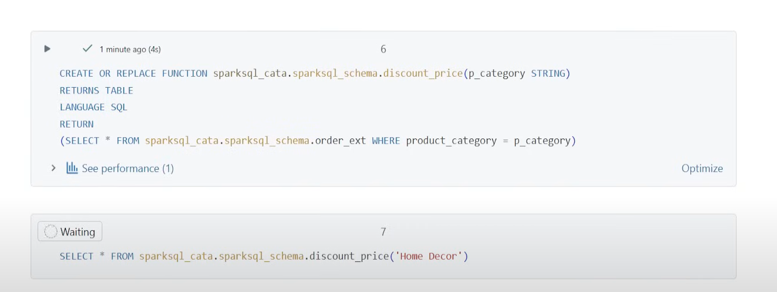
✅ Can be reused across notebooks and SQL queries.

🧪 Pandas UDF Example (Vectorized)
from pyspark.sql.functions import pandas_udf
from pyspark.sql.types import IntegerType

@pandas_udf(IntegerType())
def get_name_length_batch(names):
return names.str.len()

df = df.withColumn("name_length", get_name_length_batch(df.name))
✅ Much faster for large datasets due to vectorized execution.

✅ Best Practices
- Prefer built-in Spark functions when possible (they’re optimized)
- Use Pandas UDFs for performance on large datasets
- Register UDFs with Unity Catalog for governance and reuse
- Avoid UDFs in performance-critical ETL unless necessary

Data masking

🧠 What is Dynamic Data Masking?
Dynamic Data Masking (DDM) is a security feature in SQL Server (2016+) and Azure SQL that obscures sensitive data in query results for non-privileged users — without changing the actual data in the database.
🔐 Purpose:
- Prevent unauthorized access to Personally Identifiable Information (PII) or confidential fields
- Simplify application-layer security
- Comply with data protection regulations (e.g., GDPR, HIPAA)

⚙️ How It Works
- Masking is applied at query time, not during storage
- Privileged users (e.g., DBAs) see full data
- Non-privileged users see masked values
- No changes required in application code

🧪 Masking Functions
Type | Description | Example Output
Default | Full mask based on data type | 'XXXX', 0, 1900-01-01
Email | Shows first letter, masks rest | gXXXX@XXXX.com
Partial | Shows part of string, masks middle | GXXXi
Random | Replaces numeric with random value in range | 2, 4, 5
Datetime | Masks portions of date/time (SQL Server 2022+) | 1900-01-01 00:00:00

🧮 Example: Creating a Masked Table
CREATE TABLE EmployeeData (
MemberID INT IDENTITY PRIMARY KEY,
FirstName VARCHAR(100) MASKED WITH (FUNCTION = 'default()'),
LastName VARCHAR(100) MASKED WITH (FUNCTION = 'partial(1,"XXX",1)'),
Email VARCHAR(100) MASKED WITH (FUNCTION = 'email()'),
Age INT MASKED WITH (FUNCTION = 'default()'),
JoinDate DATE MASKED WITH (FUNCTION = 'default()'),
LeaveDays INT MASKED WITH (FUNCTION = 'random(1,5)')
);

🔍 Viewing Masked Data
SELECT * FROM EmployeeData;
- Non-privileged users will see masked values
- Privileged users (with UNMASK permission) will see real data

🔐 Granting Access to Unmasked Data
GRANT UNMASK TO [username];

✅ Best Practices
- Use DDM with encryption, auditing, and row-level security
- Apply masks only to sensitive columns
- Use Database Migration Assistant to identify masking candidates
- Avoid relying solely on DDM for full data protection

🧠 Concept: Column Masking with UDFs in Unity Catalog
Unity Catalog allows you to apply column-level masks using SQL UDFs, so that sensitive data (like emails, SSNs, or names) is automatically transformed at query time — based on user identity or role.
🔐 Why Use UDFs for Masking?
- Custom logic beyond built-in masking functions
- Reusable across tables and columns
- Supports conditional masking (e.g., based on user role or column value)

🧪 Step-by-Step: Masking with SQL UDF
1️⃣ Create a SQL UDF for Masking
CREATE FUNCTION main.secure.mask_email(email STRING)
RETURNS STRING
RETURN CONCAT(SUBSTRING(email, 1, 1), '***@***.com');
This UDF masks the email, showing only the first character.

2️⃣ Apply the UDF as a Column Mask
CREATE TABLE main.secure.customers (
id INT,
name STRING,
email STRING MASKED WITH (FUNCTION = 'main.secure.mask_email')
);
Now, whenever a non-privileged user queries email, they’ll see the masked version.

3️⃣ Grant Access to See Unmasked Data (Optional)
GRANT SELECT ON TABLE main.secure.customers TO `analyst_role`;
GRANT EXECUTE ON FUNCTION main.secure.mask_email TO `analyst_role`;
You can control who sees masked vs. real data using roles and grants.

✅ Best Practices
- Keep UDF logic simple and performant
- Use Unity Catalog’s Catalog Explorer to manage masks visually
- Combine with row filters for full fine-grained access control
- Audit masking behavior for compliance
Here’s a clear explanation of the is_account_group_member() function in Databricks SQL, Ganapathi — especially relevant if you're working with Unity Catalog and implementing fine-grained access control:

🧠 What is is_account_group_member(group)?
This function returns TRUE if the current user is a direct or indirect member of the specified account-level group.
🔐 Key Points:
- Works only with Unity Catalog
- Checks account-level groups, not just workspace-local groups
- Useful for row-level security and column masking
- Helps enforce role-based access across workspaces

🧪 Syntax
is_account_group_member('group_name')
- group_name: A string representing the account-level group name
- Returns: BOOLEAN (TRUE or FALSE)

✅ Example Usage
🔍 Row-Level Filter in a View
CREATE OR REPLACE VIEW secure_view AS
SELECT *
FROM sensitive_table
WHERE is_account_group_member('finance_team');
Only users in the finance_team group will see rows from sensitive_table.

🔄 Comparison: is_account_group_member vs is_member
Function | Scope | Works With Unity Catalog | Checks Account-Level Groups
is_account_group_member | Account-wide | ✅ Yes | ✅ Yes
is_member | Workspace-local | ✅ Yes | ❌ No (only local groups)

🔐 Granting Access
To use this function effectively, make sure:
- Groups are defined at the account level in Unity Catalog
- Users are assigned to those groups via SCIM or admin console
- You apply it in views, row filters, or column masks

🧠 Masking based on groups in Databricks
Mask sensitive columns (e.g. SSN, email) unless the querying user is a member of a specific account-level group, such as 'FinanceTeam'.

🧪 Step-by-Step Implementation
1️⃣ Create a SQL UDF for Masking
CREATE FUNCTION main.secure.mask_ssn(ssn STRING)
RETURNS STRING
RETURN CASE
WHEN is_account_group_member('FinanceTeam') THEN ssn
ELSE '***-**-****'
END;
This function checks if the user belongs to the FinanceTeam group:
- ✅ If yes → shows the real SSN
- ❌ If not → returns a masked value

2️⃣ Apply the Mask to a Column
CREATE TABLE main.secure.employees (
name STRING,
ssn STRING MASKED WITH (FUNCTION = 'main.secure.mask_ssn')
);
Now, any query on employees will automatically apply the mask to the ssn column based on the user's group membership.

3️⃣ Query Behavior
- 👤 FinanceTeam member sees:
James | 123-45-6789
- 👤 Other users see:
James | ***-**-****

✅ Best Practices
- Use descriptive group names tied to business roles
- Register masking functions in a secure schema (e.g. main.secure)
- Combine with row filters for layered security
- Audit access and masking behavior for compliance

ROW LEVEL SECURITY

🧠 What is Row-Level Security?
Row-Level Security ensures that users only see the rows they’re allowed to see, based on their identity. The filtering happens inside the database, automatically, every time a query runs — no need to modify application logic.

🎯 Scenario: Sales Data Access by Salesperson
You have a table called Sales with records for multiple salespeople. You want each salesperson to see only their own sales.

🧪 Step-by-Step Implementation
1️⃣ Create the Sales Table
CREATE TABLE Sales (
SaleID INT PRIMARY KEY,
SalesPerson NVARCHAR(50),
Country NVARCHAR(50),
Amount DECIMAL(10,2)
);
2️⃣ Insert Sample Data
INSERT INTO Sales VALUES
(1, 'Alice', 'USA', 1000),
(2, 'Bob', 'USA', 1500),
(3, 'Charlie', 'Canada', 2000);
3️⃣ Create Users (for demo purposes)
CREATE USER Alice WITHOUT LOGIN;
CREATE USER Bob WITHOUT LOGIN;
CREATE USER Charlie WITHOUT LOGIN;

GRANT SELECT ON Sales TO Alice, Bob, Charlie;
4️⃣ Create the Predicate Function
This function checks if the current user matches the SalesPerson column.
CREATE FUNCTION dbo.fn_SalesFilter(@SalesPerson AS sysname)
RETURNS TABLE
WITH SCHEMABINDING
AS
RETURN SELECT 1 AS AccessGranted
WHERE @SalesPerson = USER_NAME();
5️⃣ Create the Security Policy
This binds the function to the Sales table.
CREATE SECURITY POLICY SalesPolicy
ADD FILTER PREDICATE dbo.fn_SalesFilter(SalesPerson) ON dbo.Sales
WITH (STATE = ON);

🔍 What Happens Now?
When user Alice runs:
SELECT * FROM Sales;
She sees only:
SaleID | SalesPerson | Country | Amount
1 | Alice | USA | 1000
Same for Bob and Charlie — each sees only their own rows.

✅ Key Benefits
- No need to modify queries — filtering is automatic
- Works with SELECT, UPDATE, DELETE
- Centralized logic = easier to maintain
- Supports compliance and audit requirements

Row-Level Security (RLS) in Databricks

🧠 What is Row-Level Security in Databricks?
Row-Level Security (RLS) restricts access to specific rows in a table based on the user’s identity, group membership, or attributes. It ensures that users only see the data they’re authorized to view — directly at query time.
This is implemented using row filters in Unity Catalog, typically via SQL UDFs.

⚙️ How It Works
- You define a SQL UDF that returns TRUE or FALSE based on the current user or group.
- You apply that function as a row filter to a table.
- When users query the table, only rows that pass the filter are returned.

🧪 Example: Filter by Department Group
1️⃣ Create a SQL UDF for Filtering
CREATE FUNCTION main.secure.filter_by_department(dept STRING)
RETURNS BOOLEAN
RETURN CASE
WHEN is_account_group_member('SalesTeam') AND dept = 'Sales' THEN TRUE
WHEN is_account_group_member('FinanceTeam') AND dept = 'Finance' THEN TRUE
ELSE FALSE
END;
This function checks if the user belongs to a group and matches the department.

2️⃣ Apply the Row Filter to a Table
CREATE TABLE main.secure.employees (
id INT,
name STRING,
department STRING
)
ROW FILTER filter_by_department(department);
Now, when a user queries main.secure.employees, they’ll only see rows from their department — based on their group membership.

✅ Best Practices
- Use account-level groups via is_account_group_member() for centralized control
- Keep filter logic simple and efficient
- Combine with column masking for full data governance
- Use ABAC policies for scalable, tag-based filtering across tables

